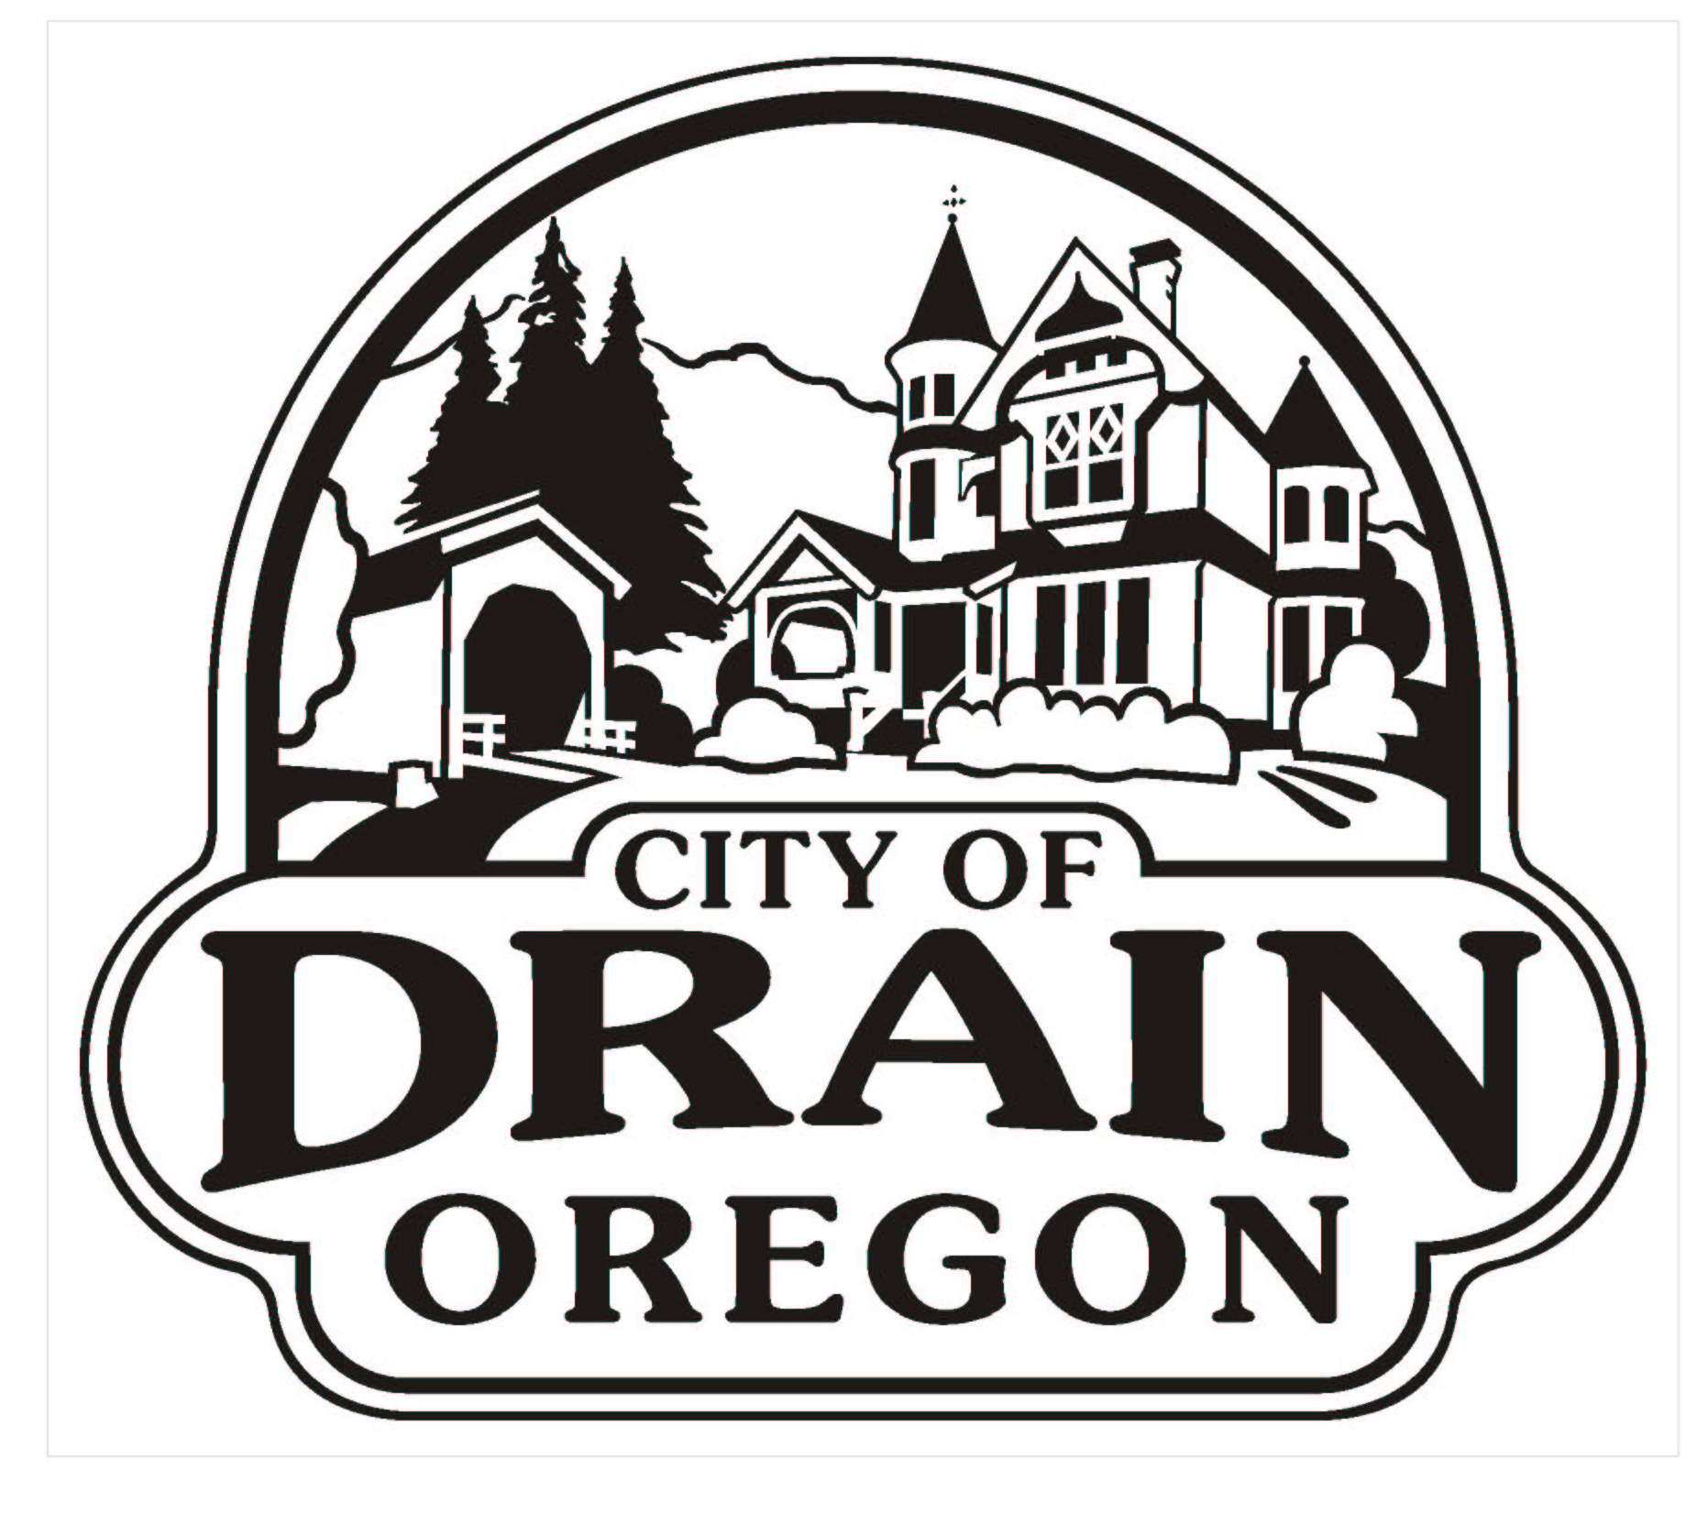

NO MORE SEASONAL SUPRISES

Now you can pay the same amount, every month, all year round with the City of Drain Equal Payment Plan. The monthly equal pay amount is calculated by adding your previous 12 months worth of usage, along with any proposed rate increase amounts. That total is then divided by 12 in order to determine an equal monthly payment.
We will continue to read your meter each month and your monthly statement will show your actual usage and charges as well as the beginning balance on the account. That way you will still know where your account stands each month.

- In order to take part in the program, your bill must be paid in full prior to beginning the program.

- You must have a minimum of one year’s service at your current address to be able to participate.

- A full payment must be made each and every month.

- Monthly payment amounts may need to be adjusted if your usage is substantially above or below the calculated payment amount or if there is any unforeseen utility rate changes.

To obtain an estimate for what your equal payment may be, please call City Hall.

129 West C Avenue P.O. Box 158, Drain, Oregon 97435-0158 (541) 836-2417

