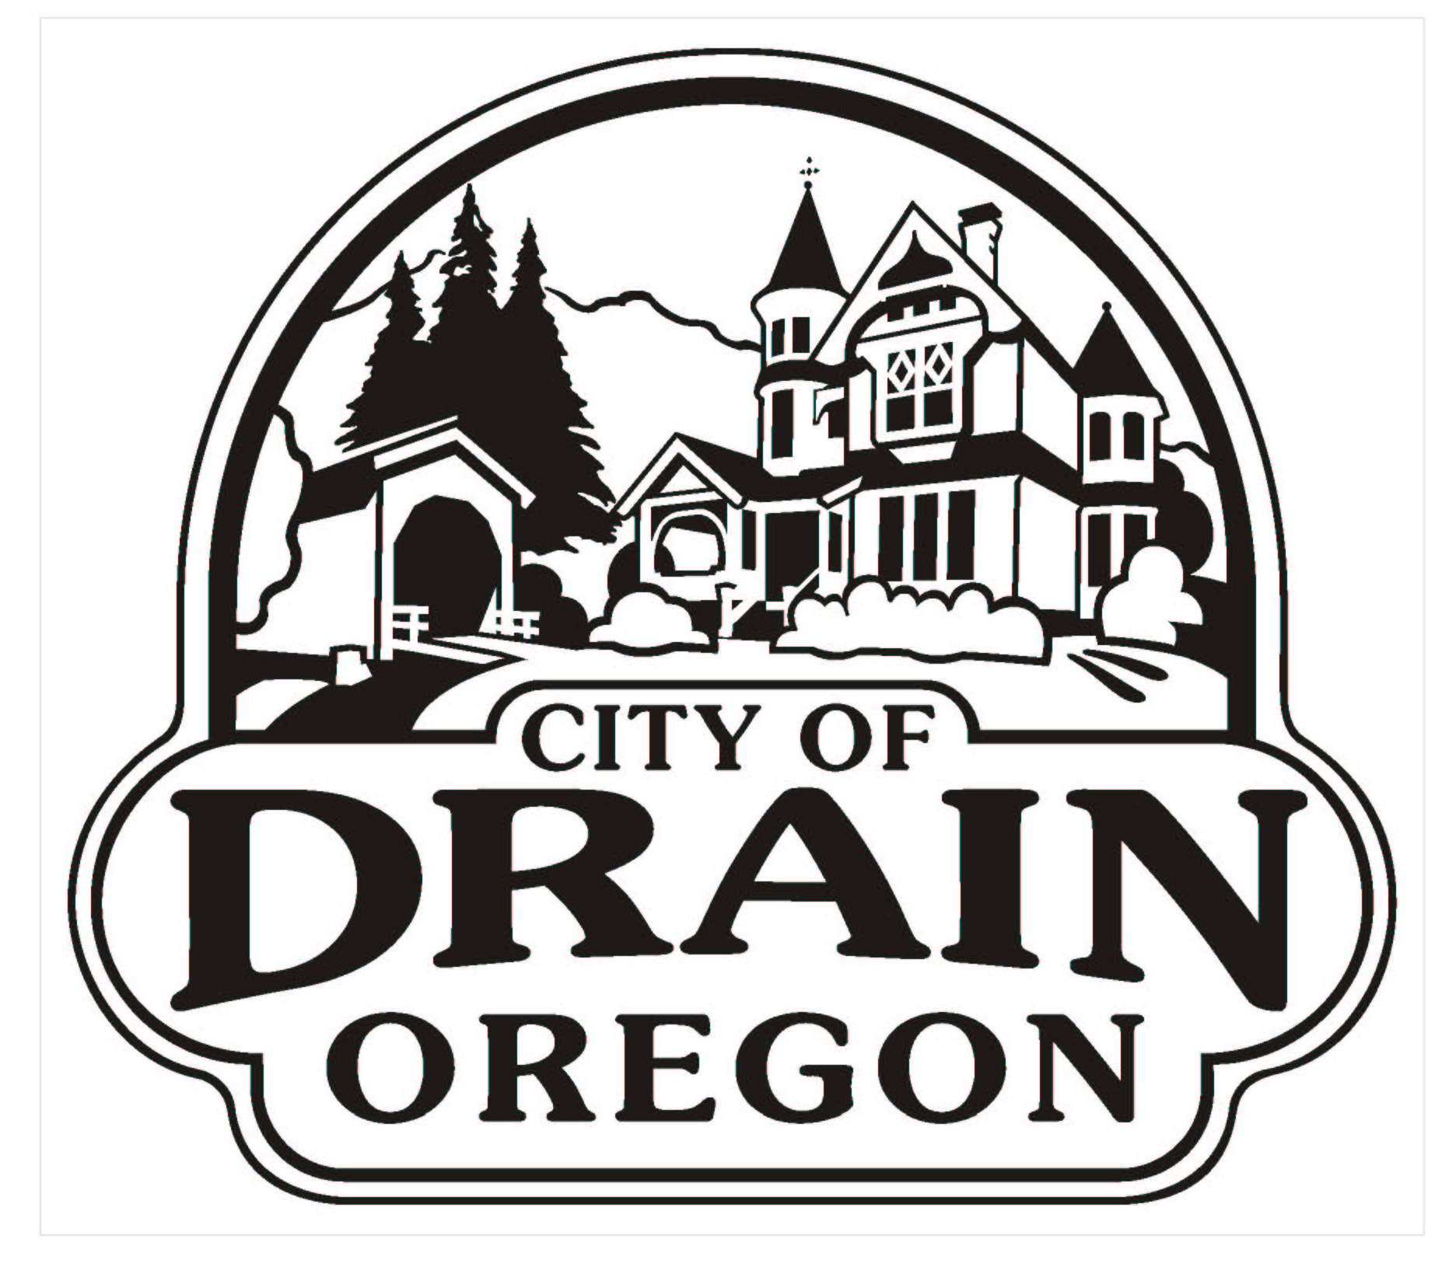

PERMIT FOR CURB CUT AND WORK IN PUBLIC RIGHT-OF-WAY

DATE: _________________________________

APPLICANT: _________________________________

_________________________________

_________________________________

TELEPHONE: _________________________________

LOCATION OF WORK TO BE DONE: ____________________________________
________________________________________________________________________
________________________________________________________________________

MATERIALS TO BE USED: __________________________________________
________________________________________________________________________
________________________________________________________________________

CONTRACTOR: ______________________________________________________

TIME WITHIN WHICH THE WORK IS TO BE DONE: ________________________

The Permittee shall be responsible for any damages made to City property or Public Utilities.

Permitee shall submit a sketch drawing showing location of work and dimensions.

PERMIT FEE:

______________________________ ____________________________
PERMITTEE’S SIGNATURE STEVE DAHL
CITY ADMINISTRATOR

This permit is permissive only, and the work to be done shall be at the sole cost and expense of the Permittee. The City is under no obligation to maintain work or make repairs thereto and the City may, at any time, interfere with the work being done under this permit, when it is necessary for the public convenience, or if in connection with the City’s maintenance, repair and construction of streets, alleys or Permittee’s property, shall not be credited with any part of the cost of the work done hereunder.

